Your guide to membership &
PLAYER REGISTRATION 2026/27

Contents
Introduction 1
Login 2
Check your personal profile 3
Mini, Junior & Colts Player Registration 3
U14 / U15 / U16 Boys 4
How to buy membership 5
Basket & Checkout 6
Roles (Coach/First Aider/Team Manager) 7

Introduction

This season, the RFU have changed the sign in route for GMS.

The RFU have introduced a process for all individual users in the Game Management System (GMS). This guide will cover how to login to the GMS, how to view your personal profile, how to purchase membership & how to register as a player.

Each age group has a representative who has been trained in GMS and can assist you with any queries you have. Please contact them to resolve any issues in the first instance.

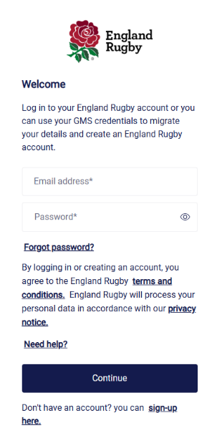
Login
To login to the RFU’s Game Management System (GMS), click on this link https://gms.rfu.com/GMS/BarkersButts
On the login screen you will be taken to the England Rugby single sign on page.

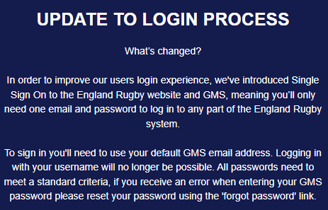

If you previously accessed GMS, please sign in using your email address registered on GMS and password.
If you do not remember your password, please select the Forgot password button on the login screen – a reset password link will be emailed to you from RFU Mail (Check junk box if not received in your inbox).
If you are new to GMS you will you need to create an account. To create a new account click on the ‘Sign up here’ link at the bottom.
If you require assistance with this please contact your Team Manager in the first instance for assistance.

Check your personal profile

Once you have logged into your account, please check your personal & contact details on your personal profile by clicking on the three dots and choose ‘edit details’

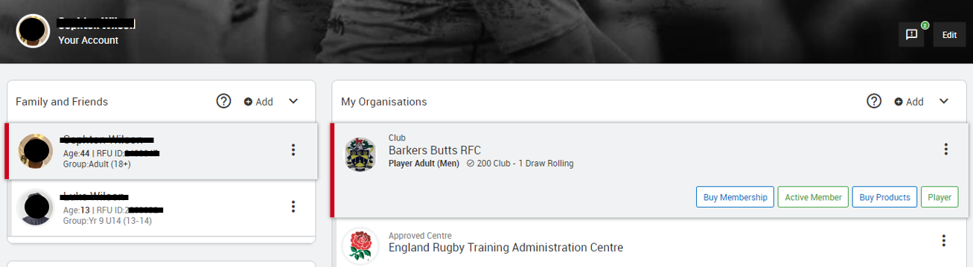

If you have a red highlighted box saying Email verification required – click on resend verification email. You will receive an email from the GMS, then follow the instructions in the email.

Mini, Junior & Colts Player Registration

Please note there is now a 2-part process (Membership & re-registration) for all Mini, Junior and Colt players. This is a mandatory requirement for them to be able to play rugby at Barkers Butts RFC.

Age Grade Player Registration is an online annual process for club players between U7 to U18. RFU Regulation 15 requires players to be affiliated annually online each season. Using the online registration removes the need for paper forms, reduces administrative burden, increases data accuracy, and places the ownership/update of data with the parents.
If you are a previous member - you will need to renew the player registration – please do not set up a new registration, as this will duplicate the record already on file.
Login to the GMS, click on your child’s tab at the top and click on Renew Registration in Quick Links.
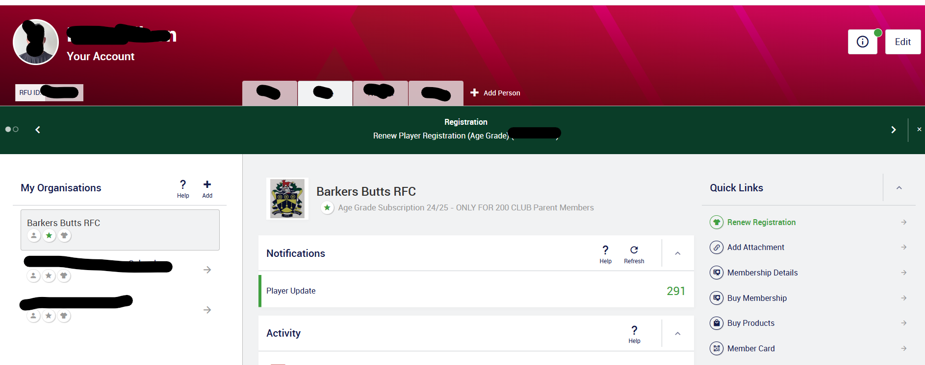
This will take you through to the Player Registration Form which will be mostly pre-populated as this is a registration renewal. Check all the details are still correct by pressing on arrows to the right to expand the section and fill out any missing details.

New for this year is you need to add your preference for contact/non-contact rugby. Younger children do not need to worry about the playing position, this only really becomes relevant from U14 onwards.

Emergency contact – use the drop down and select the parent/guardian, the rest of the box will auto-populate.

Please ensure the education tab is completed for M&J and answer the additional questions.

Once done press Submit registration Form.

U14 / U15 / U16 Boys
Please ensure you have uploaded a profile picture of your child as they are required for cup matches.
Click on the Edit button.
Click on the pencil in the image box, a tab will expand.
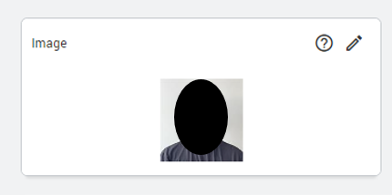
Click on the camera icon to upload an image. Use the slider to zoom in/out. Press ‘save’.

How to buy membership

On the first screen you will see a list of “My Organisations” which you are linked to, click on Barkers Butts RFC
Click on your tab at the top and click on Buy Membership in Quick Links. You will now be given a range of membership schemes to choose from.

200 club members - You must settle any membership balances before you will be able to select any discounted memberships. 200 club membership is an all year round membership, that means you should not stop your payments in the off-season. If you do, your owing balance will continue to rise and you will need to settle this in order to gain the discounted membership for your child/children. If you are an existing 200 club member, you do not need to buy another membership for yourself as it is a rolling membership.

Please refer to the Membership letter for full details on the membership options and benefits
Select the relevant membership type by clicking on the shopping basket at the righthand side of the selected type.
If you are purchasing for more than one person, click on their name from the “Select person” section and repeat the process selecting their membership type.
Discounts will show when you press checkout.
Once you have selected the membership/s you require select “View Basket”.

Basket & Checkout
A summary of the items added to your basket will now appear – if showing correctly, select “Checkout”.
Select the payment option you wish to choose and follow the online instructions.
Select pay now and enter your payment details.

You will be presented with a payment complete message once it has been processed.
Thank you - your membership has now be completed.

Roles (Coach/First Aider/Team Manager)

If you hold a role within Barkers Butts RFC your details will automatically upload to our website under the relevant Team’s page. https://barkersbuttsrfc.rfu.club/teams/barkers-butts-u14/21886/roles

If you do not want your phone number uploaded to the website, follow these instructions:-

In GMS, your personal profile go to ’phone list’ and click the three dots at the right of the number and choose ‘edit’. A tab will open.

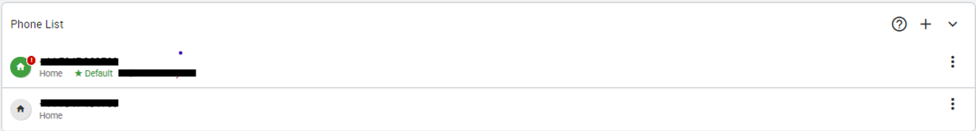

In the settings below the number, use the drop down which says ‘X directory’ and change it to ‘yes’. The click ‘save’.

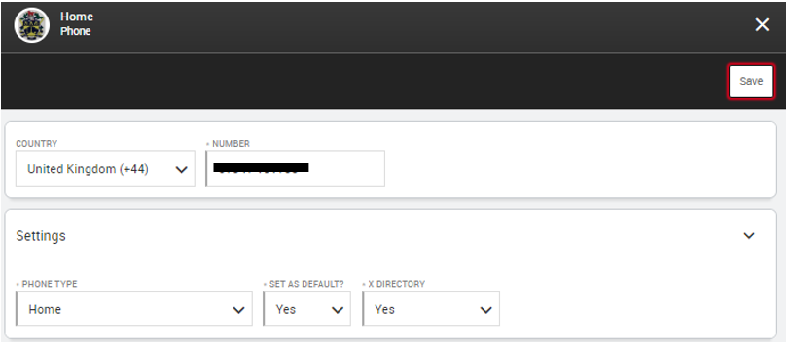

The Barkers Butts RFC website will automatically update and remove your mobile number.

